RESOLUTION NO.__________

RE: CERTIFICATE OF APPROPRIATENESS UNDER THE

PROVISIONS OF THE ACT OF THE PENNSYLVANIA

LEGISLATURE 1961, JUNE 13, P.L. 282 (53

SECTION 8004) AND BETHLEHEM ORDINANCE NO.

3952 AS AMENDED.

WHEREAS, it is proposed to construct a dormer addition to the rear portion of the third floor of a single family residential structure at 208 E. Fourth Street.

NOW, THEREFORE, BE IT RESOLVED by the Council of the City of Bethlehem that a Certificate of Appropriateness is hereby granted for the work.

Sponsored by: (s)

(s)

ADOPTED BY COUNCIL THIS DAY OF

(s)

President of Council

ATTEST:

(s)

City Clerk

HISTORIC CONSERVATION COMMISSION

CASE # 532 – It is proposed to construct a dormer addition to the rear portion of the third floor of a single family residential structure at 208 E. Fourth Street

OWNER/APPLICANT: Webster Street Holdings, LLC / James Byszewski & Louis Intile

The Commission upon motion by Mr. Cornish seconded by Mr. Silvoy adopted the proposal that City Council issue a Certificate of Appropriateness for the proposed work described herein:

1. The proposal to construct a dormer addition to the rear portion of the third floor of a single family residential structure at 208 E. Fourth Street was presented by James Byszewski and Louis Intile.
2. This is a modification to the previously approved COA.
3. Instead of the previously approved addition to the house, a new rear shed roofed dormer will be constructed at the rear of the third floor of the building.
4. There will be no modification to the existing footprint to the building.
5. All materials approved in the COA of November 2014 will be used in the new dormer addition.
6. The third floor window on the front façade of the house will be modified to be a casement window with a single horizontal muntin to give the appearance of a double hung window.
7. The existing roof replacement and new dormer roofing will be GAF Slateline shingles in the Antique Slate color.
8. The proposed motion was unanimously approved.

CU: cu

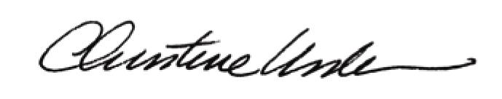

By:

Date of Meeting: February 23, 2015 Title: Historic Officer